The Summary of Automation Build Process for GrowthZone.

1. Clone the git repository on local machine.

<https://github.com/gitofhenry/AppTemplate>

1. Go to https://apps.Ionic.io, create new app and get the app ID.

For example, “1b37418b”

1. Go to <https://analytics.google.com> follow the below steps and get new Tracker ID.

In Community App account, let’s add new property to get tracking id.

This workflow is based on this link.

<https://support.google.com/analytics/answer/2587086?hl=en>

1. Go to cloned directory, make new folder with App number and add App name to app list text file. For example, “Brazilian American” app is “3” folder, copy the following files into the folder which we just created.

Config.xml, res and resources folder, settings.js

Please reference github AppTemplate config.xml and settings.js file because they has been updated, different the old files.

1. Go to <https://developer.apple.com> and make new provisioning profile. (Note: When create new App ID, certificate for push notification should be configured
2. Go to <https://www.bitrise.io> and create new app. (e.g. Brazilian American)

Repository: AppTemplate

Branch: Master

Project Build Configuration: IONIC_WORK_DIR: ./AppTemplate

IONIC_PLATFORM: ios, android

Selected stack: Xamarin Studio Stable with Xcode 8, on macOS 10.12(Sierra)

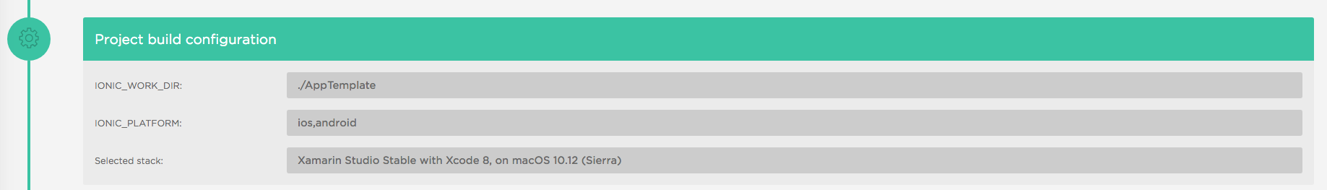

1. Go to Dashboard/AppTemplate/Settings, change app name from “AppTemplate” into “Brazilian American”
2. Go to Dashboard/Brazilian American/Code Signing and add provisioning profile and certificate. * Certificate password: vai2mni
3. Go to Dashboard/Brazilian American/Workflow Editor and configure workflow as follows.

Activate SSH key -> Git Clone Repository -> Certificate and profile install -> Run npm command -> Do anything with Script step -> Generate cordova build configuration -> Ionic Archive -> Deploy to Bitrise.io -> Deploy to iTunes Connect / TestFlight

* Do anything with Script step

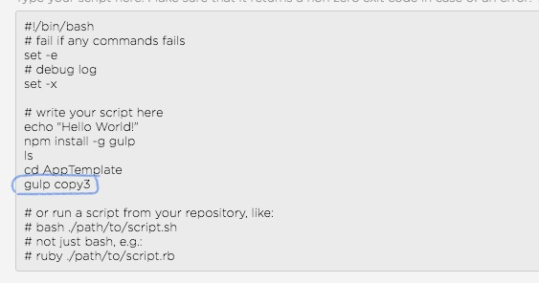

Let’s add “gulp copy(%AppNo) – For example, please see the above screenshot.

* Generate cordova build configuration

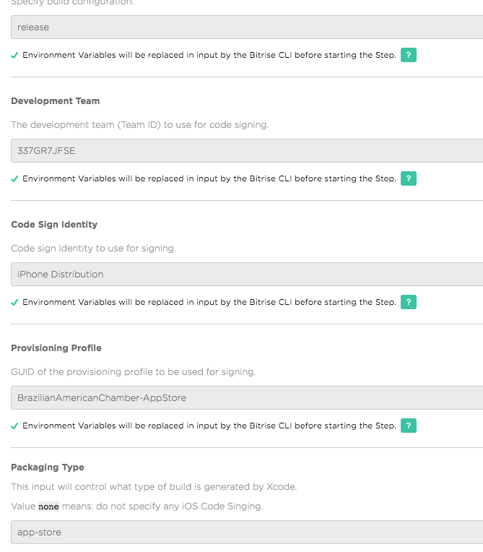

* Ionic Archive

Change build command target from emulator into device.

And Set the Cordova version to “latest”

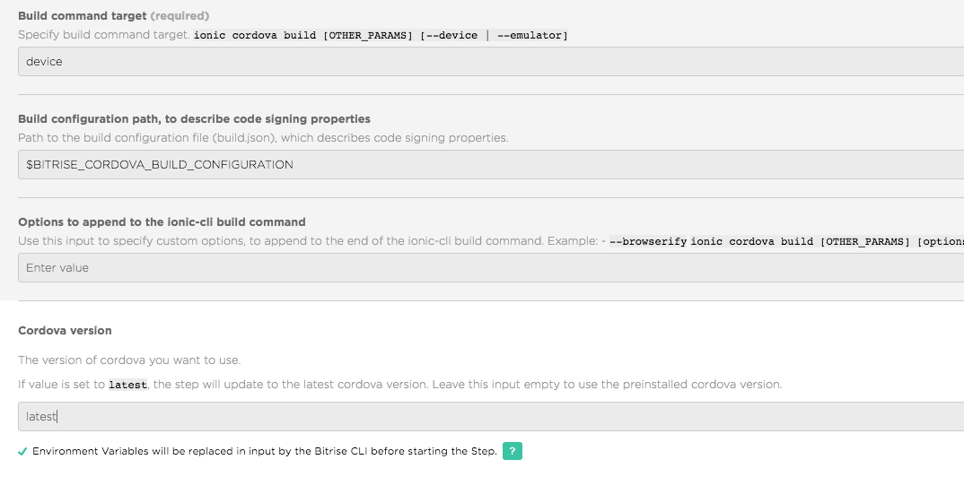

1. Go to <https://apps.ionic.io/apps/Brazilian> American Chamber/Settings/Certificates

And add certificates. Push Certificates : password 123, App Certificates : password vai2mni

1. Go to Push Settings and create new push for test.